Operational Concept Description (OCD)

LEMA Pilot School Integrated Scheduling System

Team No. 12

Name | Primary Role | Secondary Role
David Wiggins | Project Manager | Developer
Aakash Shah | Prototyper | Developer
Kushalpreet Kaur | Developer | Developer
Thammanoon Kawinfruangfukul | Tester | Developer
Eunyoung Hwang | Architect | Developer
Louis Demaria | IIV&V | Developer
Mark Villanueva | QFP | Developer
Sangik Park | Developer | Developer

04/27/2012

Version History

Date | Author | Version | Changes made | Rationale
10/09/11 | MM | 1.0 | First Draft. Additions to Introduction, & Shared Vision | Initial draft with respect to LEMA Pilot School Integrated Scheduling System Version 1.0
10/11/11 | MM | 1 | Completion of OCD | Continuation of OCD
10/14/11 | HSB, MM | 1.1 | Modification of Elements Diagram, Relation to Current System | Updating of OCD
10/17/11 | MM, AS,  HSB,  EH | 2.0 | -Updated Benefits Chain Diagram  -Updated System Boundaries, Work-flows, Artifacts, and Element Diagram Relationships | Developing the documentation for Draft FC package
10/18/11 | MM, AS | 2.1 | Updated the Element Diagram Relationships according to graded requirements | Developing the documentation for Draft FC Package
10/23/11 | MM | 2.2 | Updated Benefits Chain Diagram, Elements Diagram, Work-flows | Updating for the FC Package
11/21/11 | MM | 3.0 | Updated Work-flows, Benefits Chain Diagram, Elements Diagram | Updating for the Draft DC Package
12/04/11 | MM,AS | 3.1 | Updated Benefits Chain Diagram, Elements Diagram | Completion of Exit Criteria for DC Package
02/05/12 | EH | 4.0 | Updated the System Boundary and Environment Diagram | Updating for the Draft Rebaselined DC Package
02/07/12 | EH | 4.1 | Corrected bugs reported on Bugzilla regardomg 3.1.1 Artifacts | Updating for the Evaluation of the Draft Rebaselined DC Package
02/15/12 | TK | 4.2 | Section 1.2 | Updating for the Evaluation of the Rebaselined DC Package
03/26/12 | EH | 5.0 | Updated Benefit Chain and Artifacts | Update document following  feedback from TA and prepare for Initial Operational Capability Package
04/27/12 | TK | 6.0 | Section 1.2 | Updating for the IOC#2

Table of Contents
Operational Concept Description (OCD) i
Version History ii
Table of Contents iii
Table of Tables iv
Table of Figures v
1. Introduction 1
1.1 Purpose of the OCD 1
1.2 Status of the OCD 1
2. Shared Vision 2
2.1 Success-Critical Stakeholders 2
2.2 System Capability Description 2
2.3 Expected Benefits 3
2.4 Benefits Chain 4
2.5 System Boundary and Environment 5
3. System Transformation 6
3.1 Information on Current System 6
3.2 System Objectives, Constraints and Priorities 8
3.3 Proposed New Operational Concept 11
3.4 Organizational and Operational Implications 13

Table of Tables
Table 1: Success-Critical Stakeholders 2
Table 2: Artifacts 6
Table 3: Capability Goals 8
Table 4: Interface Requirements 8
Table 5: Organizational Goals 9
Table 6: Constraints 9
Table 7: Relation to Current System 10

Table of Figures
Figure 1: Benefits Chain Diagram of LEMA Integrated Scheduling System 4
Figure 2: System Boundary and Environment Diagram of LEMA Integrated Scheduling System 5
Figure 3: Business Workflow Diagram of Current System 7
Figure 4: Element Relationship Diagram of LEMA Integrated Scheduling System 11
Figure 5: Business Workflow Diagram of LEMA Integrated Scheduling System 12

Introduction

Purpose of the OCD
This document establishes the shared visions, requirements, and objectives of the stakeholders for The LEMA Pilot School Scheduling System. The following are the success critical stakeholders of this project:

- Beth Kennedy from LEMA Pilot School is the main project contact concerned with the production of the system
- Roberta Mailman, the APSCS, who will be the main user of the Scheduling System
- The USC Development Team

Status of the OCD
This is version 6.0 of the Operations Concept Description and is the part of the second Initial Operational Capability Package. It delineates the purpose and shared vision of the project as well as details the current and proposed business work-flows of the system. This document includes the integration with Family Accountability System as well as updated changes in artifacts and benefit diagram.

Shared Vision

Success-Critical Stakeholders
Table 1: Success-Critical Stakeholders
Stakeholder | Authorized Representatives | Organization | Relation to Benefits Chain
APSCS | Roberta Mailman | LEMA Pilot School | - Primary User of the System who Analyzes and updates the schedules
Client | Beth Kennedy | LEMA Pilot School | - Provide information and feedback to the development team.
Development Team | David Wiggins,  Aakash Shah,  Kushalpreet Kaur,  Thammanoon Kawinfruangfukul,  Eunyoung Hwang,  Louis Demaria,  Mark Villanueva,  Sangik Park | University of Southern California | - Develop the product  - Provide documentation tracing the progress  - Train the APSCS, and Client to utilize the system
Users | Students, Faculty | LEMA Pilot School | - Select their course preferences and then these courses are fed into the Scheduling System
Users | Administrators | LAUSD, LEMA Pilot School | - Set the constraints which are then applied to scheduling system in order to generate a schedule

System Capability Description
- An automated scheduling system which takes in course preferences from students through a user-friendly web interface, allowing simple course-allocation and implementation of conditional constraints as required by the delegated APSCS to output optimized schedules for students
- System allows students to register for courses and track their progress towards higher education by viewing what chance they stand to enroll into colleges depending on their grades
- The target customer for this system would be other such pilot schools looking to integrate a scheduling system at a minimal cost
- There is a need for an automated system, making the process time efficient and not labor intensive
- With the output of optimized schedules, the percentage of graduating students will be increased

Expected Benefits
- It fits LEMA’s mission to allow students to explore and view the class preferences so as to track their progress towards graduation

- An interactive user interface which makes use of a Student Selection process, enabling students to create a 'wish list' of their course preferences and thereby experience a college registration system

- The main reason for implementation would be to do away with the need for a paper-based system making the process time efficient and not labor intensive

- This system accounts for the entry of room assignments and common conference periods (for grade levels or team teaching) as well.

- Ability to calculate the optimum schedules or alternative permutations of schedules for the students as well as teachers, while taking into consideration the conflicts, class size mandates, etc. according to the conditions that are chosen by the APSCS; thereby reducing time and effort spent by shifting to a more automated process

Benefits Chain
Figure 1: Benefits Chain Diagram of LEMA Integrated Scheduling System
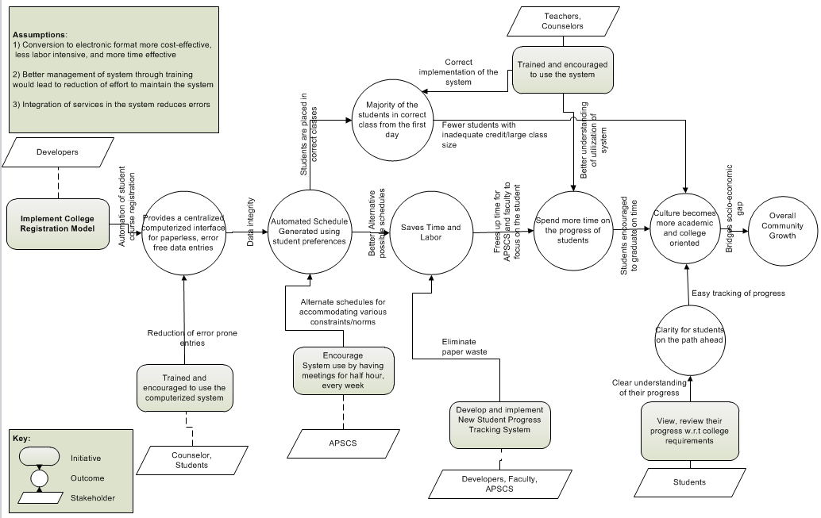

System Boundary and Environment
Figure 2: System Boundary and Environment Diagram of LEMA Integrated Scheduling System
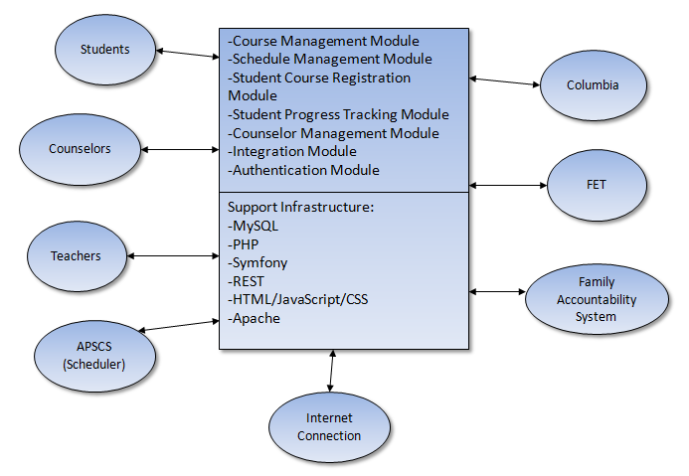

System Transformation

Information on Current System

Infrastructure
The current system's infrastructure is a combination of manual input, and the systems provided by LAUSD: SIS and Columbia.
SIS – Is a Cobol-based student record system. This system is responsible for keeping a log of the student, their progress through High School, and their graduation requirements based on the A-G curriculum.
Columbia – Is a system which generates optimized schedules for students and teachers. This system receives its inputs from SIS, which have been manually adjusted on the basis of the preferences as provided by the teachers. This is then fed into Columbia, which generates the schedules. However, this system does not provide optimized schedules, and therefore, has to be manually manipulated in order to attain the highest level of optimization.

Artifacts
Table 2: Artifacts
Artifact | Description | Requested/  Shown/Receive | Planned delivery date
LAUSD norms | The LAUSD provides norms which details the specific class size, etc that the scheduling system will need to adhere to | Received | 28th October, 2011
Scheduling constraints | Are rules that aid in the filtering and creation of the optimized schedule | Received | 19th October, 2011
Student Data & Preference | Courses that are selected by the students based on their preferences | Received | 28th October, 2011
Course Information | Information about the core courses that are a part of the A-G curriculum, as well as those offered as electives | Received | 28th October, 2011
Teacher Data & Preference | Data provided by the teachers according to their preference. For eg. Room, course preferences | Received | 28th October, 2011
Graduation and A-G requirements | 2011-2012 graduation requirements and minimum college admission A-G requirements | Received | 25th January, 2012
Student Grade Statistics | Student’s cumulative records including the information how many credits required, passed, failed, and in progress. Also it provides the student’s grade for each course | Received | 18th February, 2012
Performance Review Form | The form student write down their own grade overall high school period | Received | 18th February, 2012
Spring 2012 Student List | Student’s basic information who is taking classes in Spring 2012 | Received | 29th February, 2012
District Course List | Course list provided by LAUSD with the information about A-G requirements, grade level, course id and name | Received | 16th March 2012

Current Business Workflow
Figure 3: Business Workflow Diagram of Current System
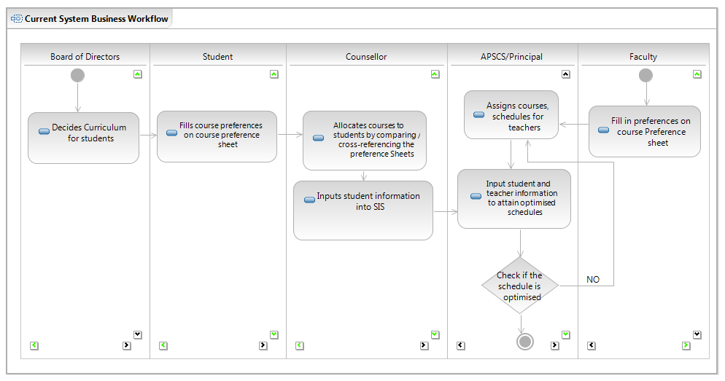

System Objectives, Constraints and Priorities

Capability Goals
Table 3: Capability Goals
Capability Goals | Priority Level
OC-1 Automated Schedule Generation: The system should enable the APSCS to use the student-entered preferences to define classes for the semester; map teachers to these classes; add additional constraints/rules, and have the system generate a final optimized schedule | Must Have
OC-2 Student Course Registration: The system should allow students to enter their course preferences for the semester; view their default sets of courses for the semester. The system should also allow counselor to approve or deny student's course registration | Must Have
OC-3 Segmentation of Classes: The system should allow the segmentation of classes determined by the number of students registered and the LA USD norms for maximum and minimum number of students in the class | Should Have
OC-4 Student Progress Tracking: Allows the student to track their progress through the A-G curriculum, check their graduation requirements, grades, and the progress towards the prerequisite college credits | Should Have
OC-5 Database Management: The system should allow the importing and exporting of data to and from the System in .csv format | Must Have
OC-6 User Interface: A simple and intuitive user interface that is easily navigable and informative for the teachers, students, counselors, APSCS. | Must Have
OC-7 Level of Normalization: The introduction of a school code which will enable the scheduling system to be ubiquitous | Want to Have
OC-8 Integration with Family Accountability System: Integration with Team 4 to get student details, grades, as well as permissions for access | Must Have

Level of Service Goals
Table 4: Interface Requirements
Interface Requirements | Priority Level
LOS 1- The system will provide an intuitive User interface in order to provide ease of usability | Must have

Organizational Goals
Table 5: Organizational Goals
Organizational Goals
OG-1: With the introduction of an efficient scheduling system, the students will be able to graduate on time, thereby fulfilling the primary mission of LEMA Pilot School
OG-2: The scheduling system reduces the load on the APSCS, making the process less labor and time intensive
OG-3: The student tracking progress system enables the students to experience a college registration system, to gear them towards tracking their own graduation requirements, grades, etc. Thereby preparing them for undergraduate studies.

Constraints
Table 6: Constraints
Constraints
CO-1: Low Monetary Budget: As LEMA Pilot School is part of a non-profit organization, the selected software to be integrated with the system must be free or of a low budget(<$1000)
CO-2: Delivery Time: The client has requested for the delivery of this system by the end of the next semester

Relation to Current System
Table 7: Relation to Current System
Capabilities | Current System | New System
Roles and Responsibilities | -The principal does all the scheduling.  -The students fill in the paper-based forms. | -The scheduling system does the scheduling.  -Students fill online request forms.
User Interactions | -The students fill in paper based forms that go to the counselor. -The principal schedules the curriculum based on student requests, teacher availability, school requirements and LAUSD constraints . | -The students, teachers, counselor and Administrator interact with the new scheduling system.  -The Scheduling System works according to the LEMA school requirements and LAUSD constraints.
Infrastructure | Due to there being a paper-based system, there is a wastage of infrastructure. | Paperless system resulting in an economical system, saving costs on infrastructure.
Stakeholder Essentials and Amenities | -Current system is labor intensive, and doesn't have the automated features and is low on amenities | -Allows students to experience a college registration system  -Helps to reduce work for APSCS  -Computerization utilizing an electronic interface
Future Capabilities | -No possible features may be added. | -Should be able to be applied to the other such Pilot schools and include more features like graphical representation of student progress.

Proposed New Operational Concept

Element Relationship Diagram
Figure 4: Element Relationship Diagram of LEMA Integrated Scheduling System
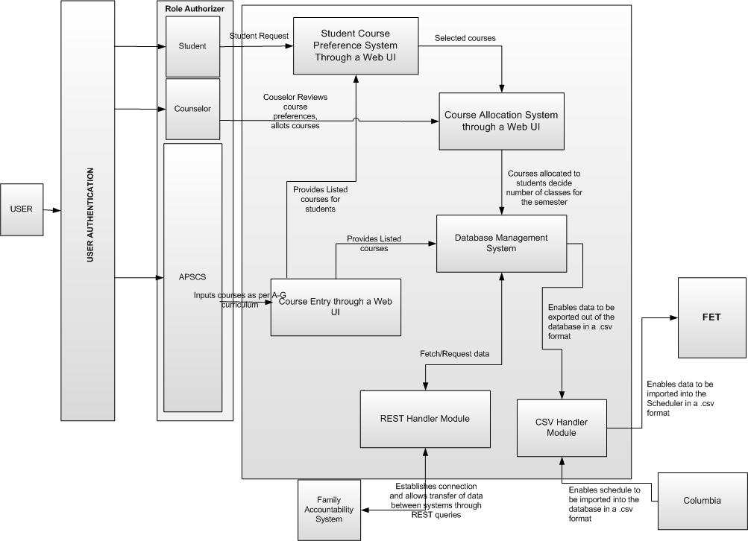

Business Workflows
Figure 5: Business Workflow Diagram of LEMA Integrated Scheduling System
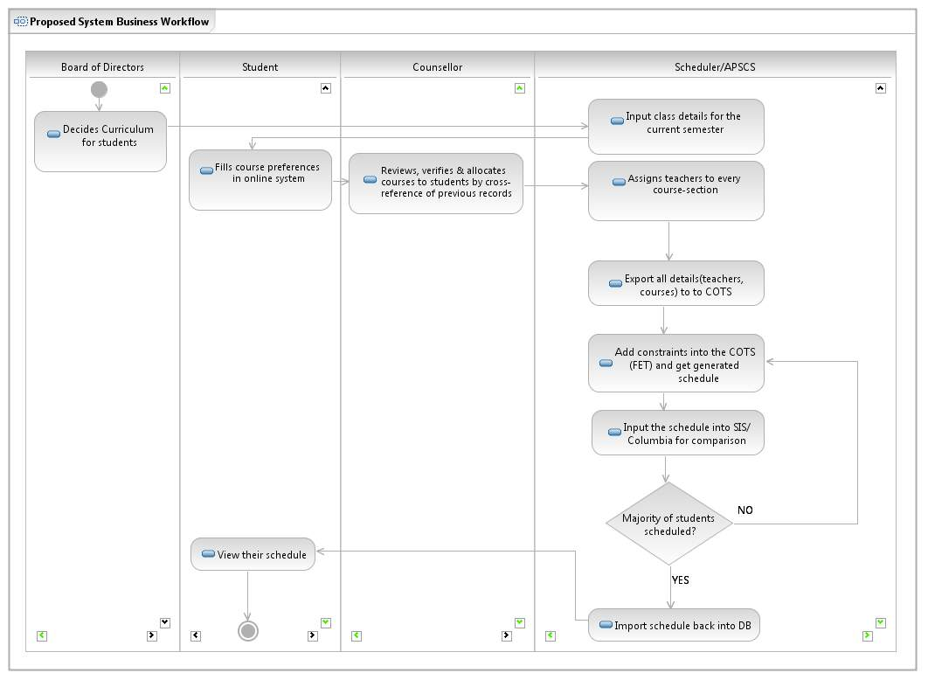

Organizational and Operational Implications

Organizational Transformations
- There will be a need to train the APSCS to effectively use the proposed scheduling system, especially when entering the constraints and rules for generating the optimized schedule

  - A simple and intuitive user interface will enable students to experience a college registration system instead of going through a more manual intensive process

Operational Transformations
- Due to a more automated process that will be followed, there will be a reduction of manual effort and therefore an elimination of paper work that is currently being followed. For eg, currently, students are filling in their course preferences on a sheet of paper which is later entered into the SIS system by the counselor. With the introduction of a simple user interface, the students will have to enter their 'wish list' directly into the system which will be stored in a centralized database

